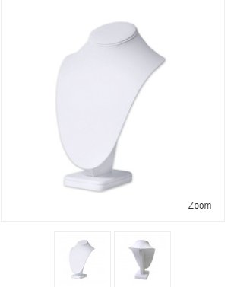
$1.00 EACH
White velveteen 9” H X 7” W
50+ available for sale. Buy as many as you want.
Used but in good condition.
Available on Fire Mountain Gems for $16.57

____________________________________________________________________________________
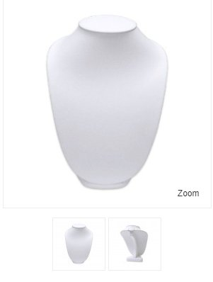
$10 SOLD
White velveteen 15” H X 10.5W
1 available for sale
Excellent condition
Available on Fire Mountain Gems for $26.63

_____________________________________________________________________________________

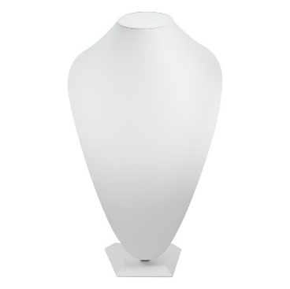
$20 Each SOLD
1 Ivory Velvet Display 15” H X 10” W
1 Ivory Faux Leather Display 15”H X 10” W
2 wire tabs on the back to secure chains
Excellent Condition
Available on Rio Grande for $52.00
Call Gwen Hertz at 352-789-5239

